**AMD Application Use Tutorial: Configuration and Recording**

To access the application, enter your email address, password and then press the "LOG IN" button

.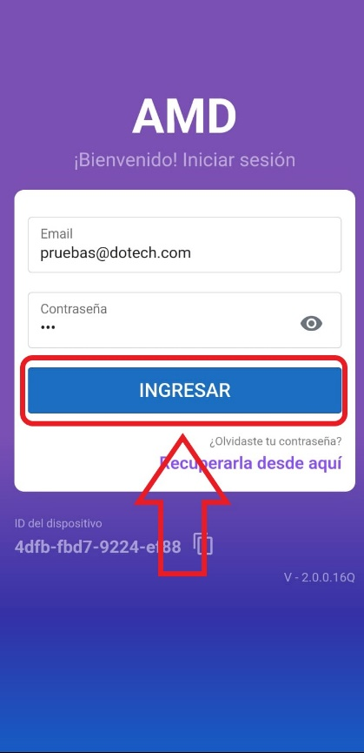

User: [pruebas@dotech.com](mailto:pruebas@dotech.com)

Pass: 123

When you open the app, you will be directed to the home screen. In your first session, you will find two important notices: "Update Pending" and "Camera Calibration".

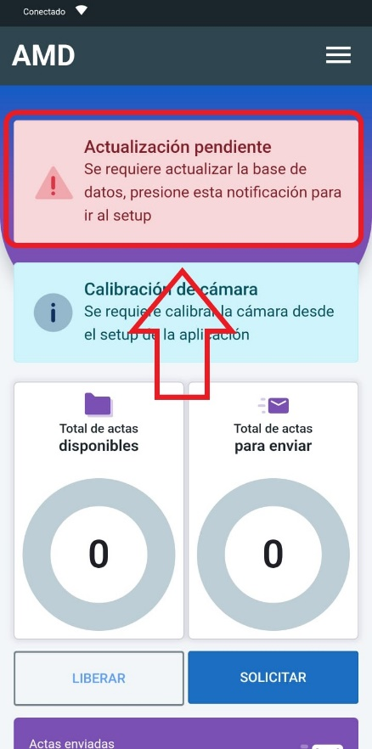

The next step is to select the “Update pending” banner. The app will take you to the settings screen, where you need to choose the “UPDATE” option.

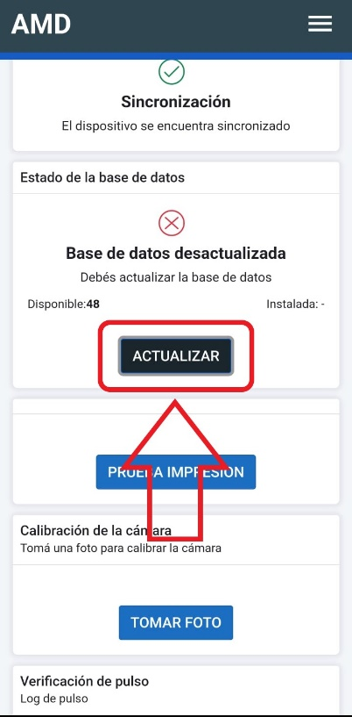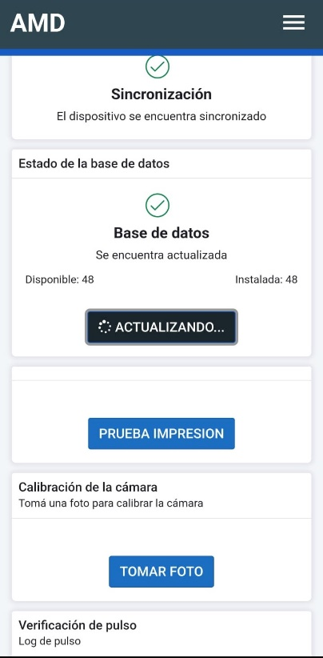

Once the update is complete, you will see the following notice. You must press "Continue" to proceed.

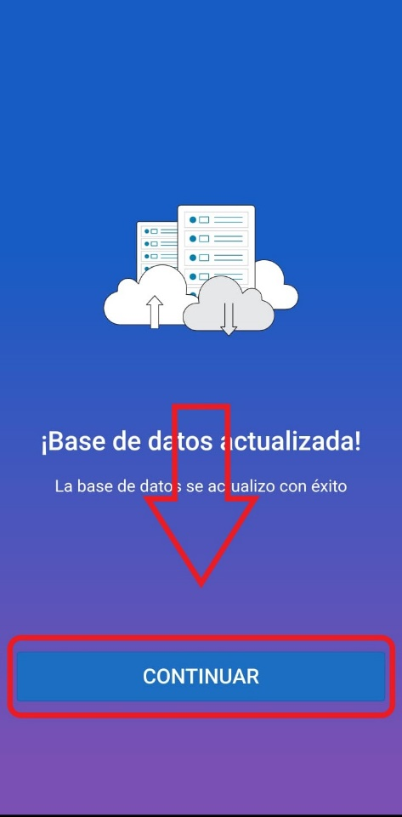

Then, scroll down the settings screen and select the “Take Photo” button to calibrate the device's camera.

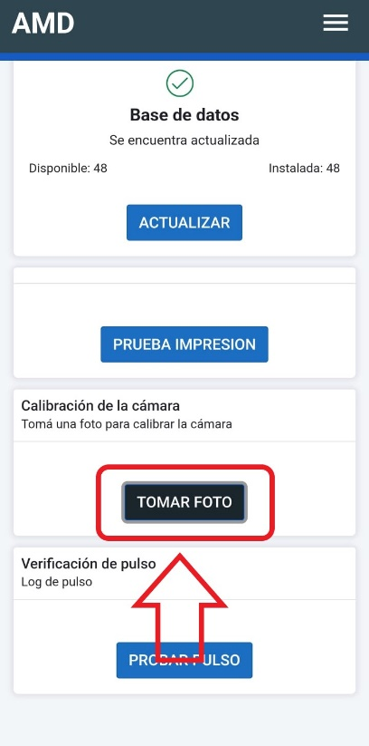

The app will ask to take two photos (depending on the device). Once the camera has been successfully calibrated, you will see the message “Quality Rating Excellent.”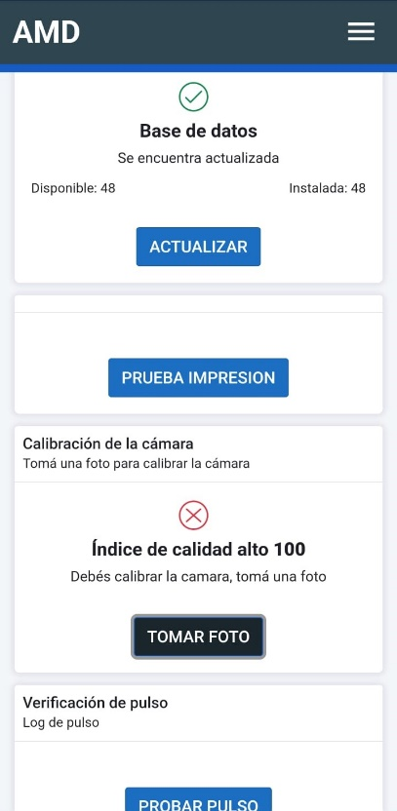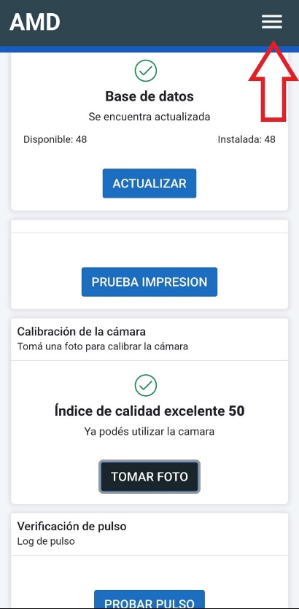

At this point, the device is configured and ready to operate normally. To begin writing violations reports, it is necessary to have violation reports available. To do so, go to the home screen and select “Request violation reports.”

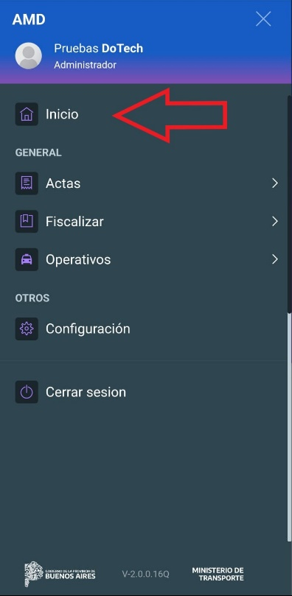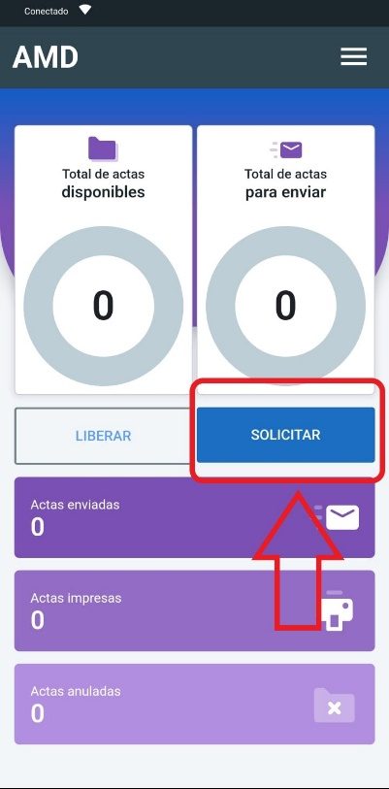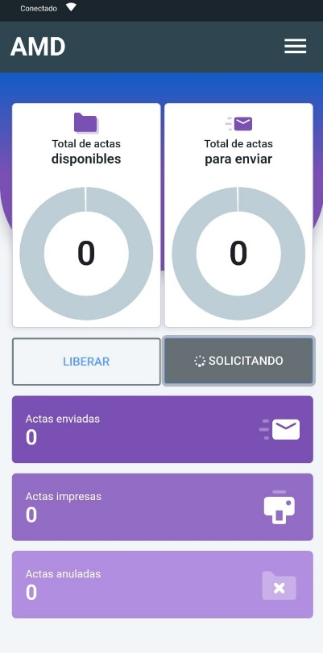

The device is now configured and ready to use, with violations reports available to use. You can check the number of available violetions reports directly on the home screen.

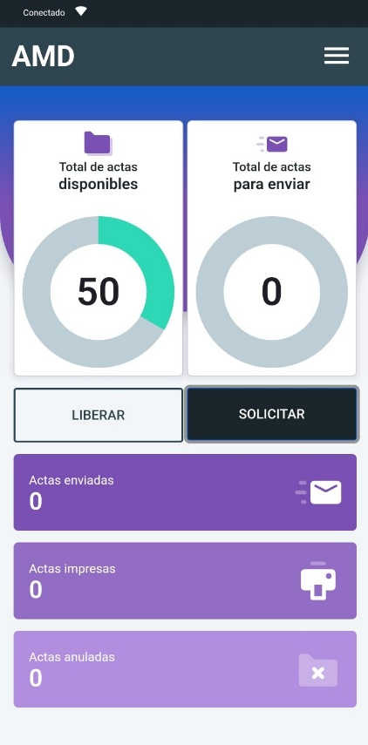

To start making minutes, simply select "Labrar acta" from the menu.

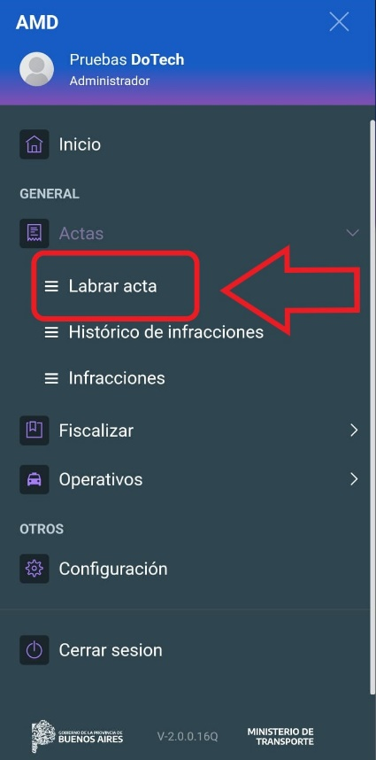

By pressing the "Labrar acta" option, the system will take you to the corresponding form. In this section, you must complete the necessary fields to prepare the “acta” (violation report). You can use test data to speed up the process, such as entering "1111" in the text fields or selecting random items where necessary.

It is essential to upload the seven photos required for each record:

1. Foto del dominio / Photo of the domain.
2. Foto del frente de la licencia de conducir / Photo of the front of the driver's license.
3. Foto del dorso de la licencia de conducir / Photo of the back of the driver's license
4. Foto del alcoholímetro / Photo of the breathalyzer
5. Foto de la retención del vehículo / Photo of the vehicle retention
6. Foto opcional 1 / Optional photo 1
7. Foto opcional 2 / Optional photo 2

Once you have completed the fields, press the “GUARDAR INFRACCION” button.”

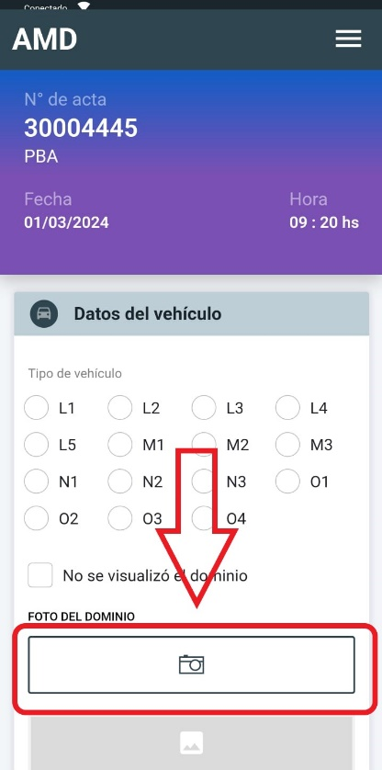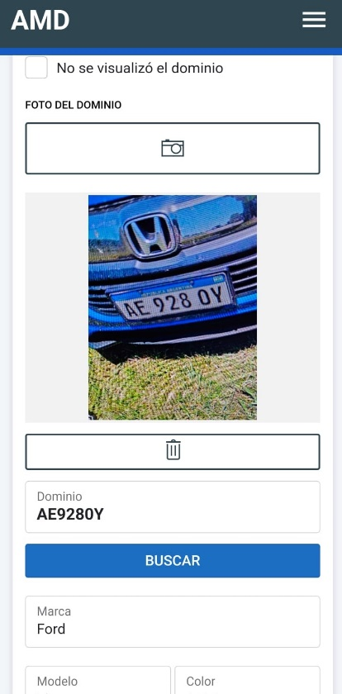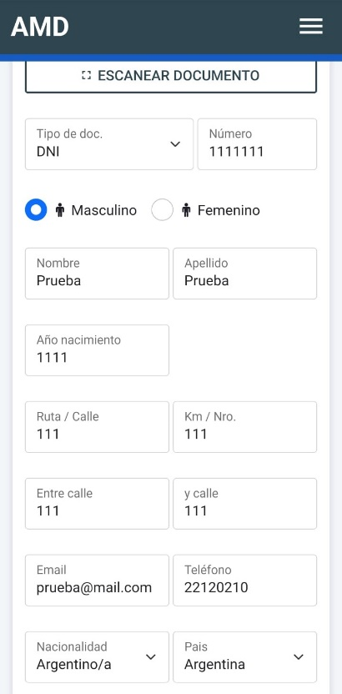

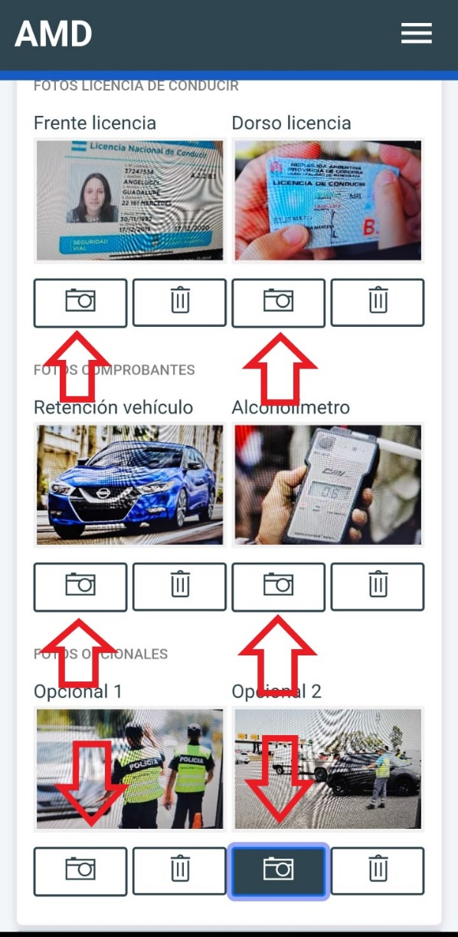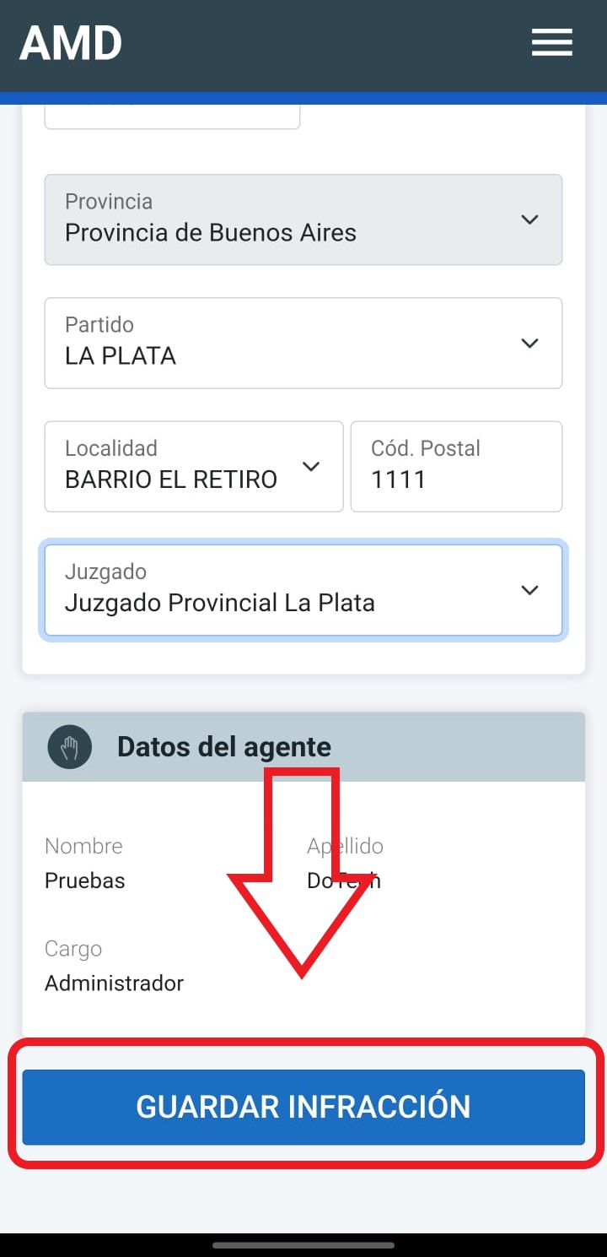

If there are incomplete required fields, the application will tell you which fields you must complete before you can save the record in the system. Once all required fields are complete, the record will be uploaded correctly. Then, press the "Labrar otra" button to repeat the process until you get the required result.

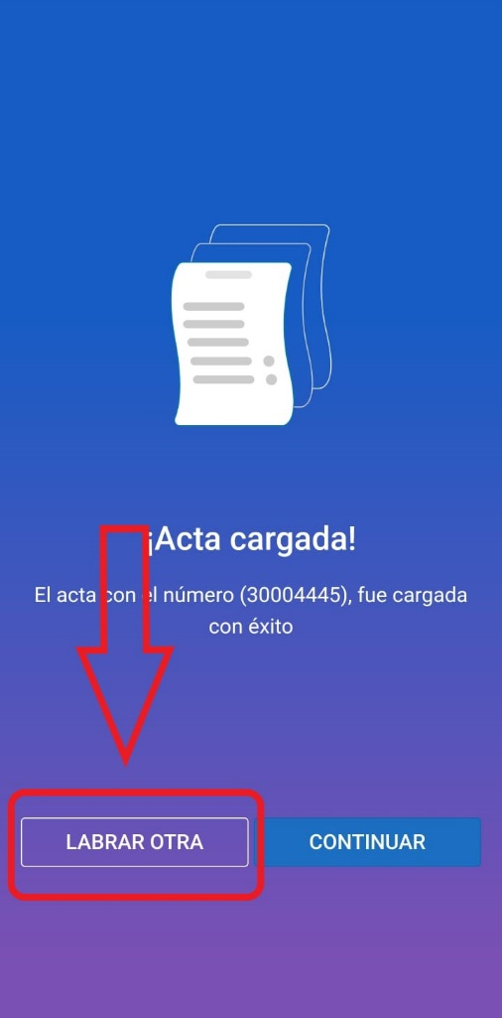

Sometimes we had to create several violations reports for the application to break. It always happens when you return from taking the photo